**Digital Logic Design Project**

**Gas Leakage Detection System**



Session: 2022 – 2026

**Submitted by:**

Faizan Ahmed Mirza 2022-CS-120

Abdul Wasay Huzaifa Malik 2022-CS-145

Robass Atif 2022-CS-150

Mohammad Abdullah 2022-CS-155

**Submitted to:**

Sir Waseem

Department of Computer Science

**University of Engineering and Technology**

**Lahore Pakistan**

Table of Contents

1. Introduction3
2. Components3
3. Description3
4. Uses4
5. Procedure4
6. Code4
7. Conclusion5

* **Introduction**

The gas leakage detection system is a detecting device which detects the gas leakage and then communicates it to the people. This device have great potential in real life applications.

* **Components**

1. Breadboard
2. NodeMCU ESP8266
3. 5V Battery
4. MQ-6 Gas Sensor
5. 1x Red LED
6. 1x Green LED
7. Resistors
8. Jumper Wires
9. USB Data Cable

* **Description**

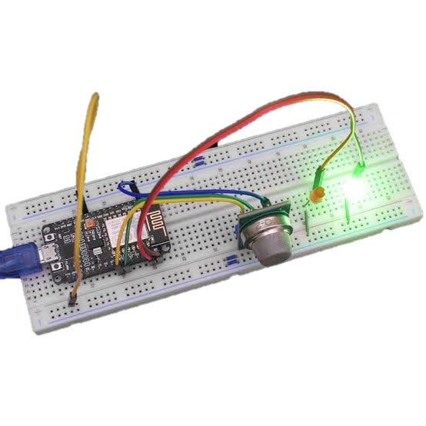The gas leakage detection system has been made using the components mentioned above. It detects the gas within the sensors range and then alerts the person around by lighting up the red LED. The system has been designed using NodeMCU micro controller. The code for the detection system is uploaded on this microcontroller. The analog input pin of NodeMCU is connected with analog output pin of MQ-6 gas sensor. The microcontroller then reacts accordingly to the analog gas value provided by the MQ-6 gas sensor. If the gas value is greater than a given threshold than the red LED lights up, otherwise the green LED lights up.

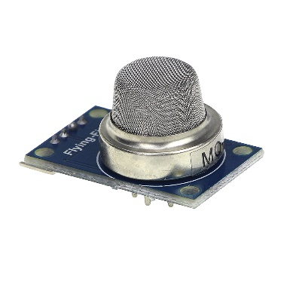

* **Uses**

1. This system can be used for domestic purposes.
2. It can be used in industries as well.
3. It can also be used commercially.
4. It not only detects gas but also detects smoke.

* **Procedure**

1. After acquiring all the required the components, the microcontroller is fitted into the breadboard.
2. Then the Vin pin of microcontroller is connected to the breadboard.
3. The G pin, which stands for ground, is also connected to breadboard using jumper wires.
4. The gas sensor is also fitted into the breadboard.
5. The Vcc and G pin of MQ-6 sensor is connected to the line where Vin and G of NodeMCU is connected, respectively using jumper wires.
6. The D1 and D2 or any other GPIO pins are connected to the breadboard where LEDs are connected.
7. The positive polarity of LED is connected to the D1 for Red and D2 for Green. The resistor should be connected before the LEDs positive leg.
8. The negative polarity of LEDs are connected to the ground.
9. Now the microcontroller is connected to the computer using USB data cable.
10. Now, the code will be uploaded to the microcontroller. The code is provided later.
11. After uploading the code, disconnect the USB data cable and then plug in the 5V battery into the breadboard with live being connected to where Vin pin of NodeMCU is connected and black to the G pin of NodeMCU.

* **Code**

The code which we uploaded in the microcontroller is given below.

const int gasSensorPin = A0;

const int redLedPin = D1;

const int greenLedPin = D2;

void setup() {

Serial.begin(9600);

pinMode(greenLedPin, OUTPUT);

pinMode(redLedPin, OUTPUT);

pinMode(gasSensorPin, INPUT);

digitalWrite(greenLedPin, LOW);

digitalWrite(redLedPin, LOW);

}

void loop() {

int gasValue = analogRead(gasSensorPin);

Serial.print("Gas Value: ");

Serial.print(gasValue);

int pinState = digitalRead(greenLedPin);

Serial.println(pinState);

if (gasValue > 2000) {

digitalWrite(greenLedPin, LOW);

digitalWrite(redLedPin, HIGH);

} else {

digitalWrite(greenLedPin, HIGH);

digitalWrite(redLedPin, LOW);

}

delay(1000);

}

* **Conclusion**

To conclude, the whole project has been a great learning curve for all of the team members. The project has been a great prospect for all of us. It provided us the experience of working with the circuits and the Internet of Things related projects.